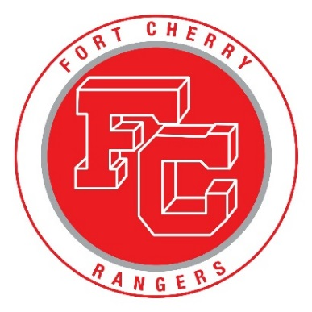 FORT CHERRY SCHOOL DISTRICT
3 YEAR –CAPITAL IMPROVEMENT PLAN

May 3, 2018
$2,000,000 Bond Issuance Timeline
Fall 2018 – Obtain $2,000,000 Bond
YEAR 1:
Summer of 2019: $673,600 in Projects
- Administration – Carpet - $8,000
- District – Van - $50,000
- Elementary – 4 Cafeteria ovens - $16,500
- Elementary – Phase 2 – Upgrading Lights to LED - $20,000
- Elementary – Phase 1 – Updating carpet in classrooms - $32,000
- Elementary – Phase 1 – Updating Rooftop condensing units - $12,000
- Jr./Sr. High – Locker Rooms (3) - $450,000
- Jr./Sr. High – Phase 2 – Upgrading Lights to LED - $25,000
- Jr./Sr. High - Phase 1 – Updating Rooftop condensing units - $10,000
- Jr./Sr. High - Phase 2 – Updating carpet in classrooms - $34,000
- Jr./Sr. High – 2 Cafeteria ovens - $8,100
- Jr./Sr. High – Main Office Carpet - $8,000

YEAR 2:
Summer of 2020: $642,300 in Projects
- Administration – Upgrading lights to LED - $7,000
- Administration – Outside Canopy - $50,000
- District – Salt Truck / Dump Truck - $62,500
- Elementary – PA System - $29,800
- Elementary – Phase 2 – Updating carpet in classrooms- $32,000
- Elementary – Phase 2 – Updating Rooftop condensing units - $12,000
- Elementary – Outside Canopy - $250,000
- Jr./Sr. High – Phase 3 – Upgrading Lights to LED - $25,000
- Jr./Sr. High – Outside Canopies - $75,000
- Jr./Sr. High - Phase 2 – Updating Rooftop condensing units - $10,000
- Jr./Sr. High - Phase 3 – Updating carpet in classrooms - $34,000
- Jr./Sr. High – PA System - $55,000

YEAR 3:
Summer of 2021: $683,000 in Projects
- District – Bread Truck - $55,000
- District – Utility Vehicle (Landscaping) - $25,000
- District – Pole Barn (Heating and Lighting Upgrade) – $10,000
- Elementary – Phase 3 – Updating carpet in classrooms- $32,000
- Elementary – Phase 3 – Updating Rooftop condensing units - $12,000
- Elementary – Driveway/Parking Lot - $100,000
- Jr./Sr. High – Driveway/Parking Lot - $150,000
- Jr./Sr. High - Phase 3 – Updating Rooftop condensing units - $10,000
- Jr./Sr. High - Phase 4 – Updating carpet in classrooms - $34,000
- Jr./Sr. High – Chimney - $130,000
- Jr./Sr. High – Gym Bleachers (Complete update) - $125,000

High School Constructed = 1959
Elementary Constructed = 1989
Renovation = 1995

ADMINISTRATION
CARPET: $8,000 (Approx.): Original - 30 years old
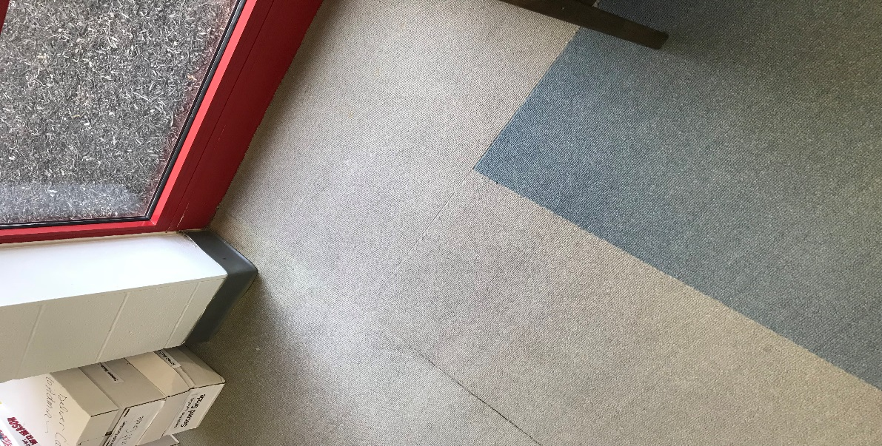
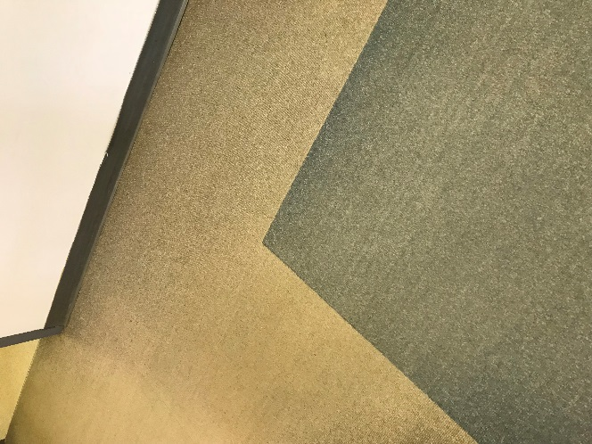

ADMINISTRATION
LED LIGHTING: $7,000 (Approx.): Original - 30 years old
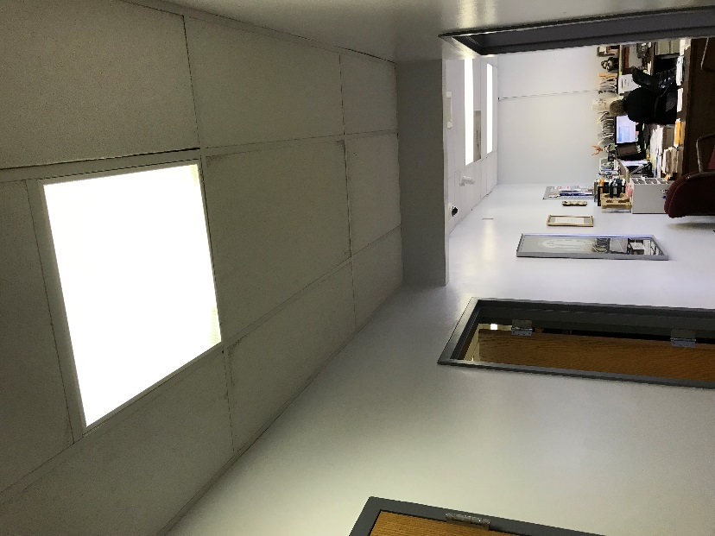

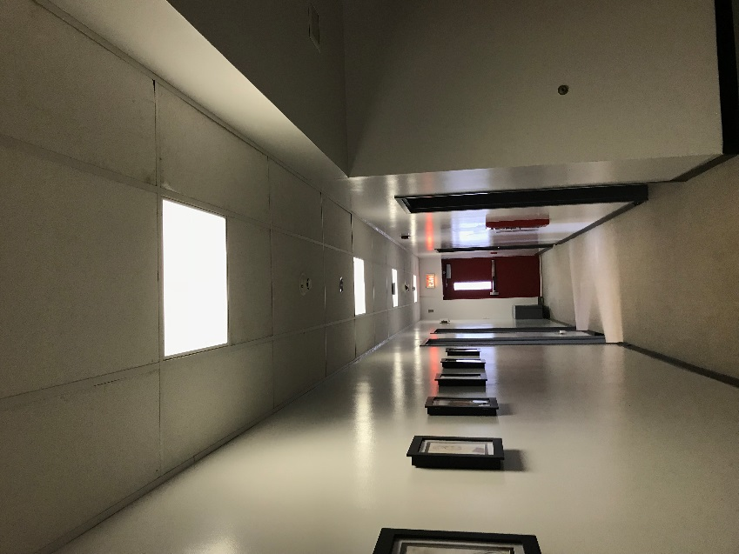
ADMINISTRATION
ENTRANCE CANOPY: $50,000 (Approx.): Original - 30 years old
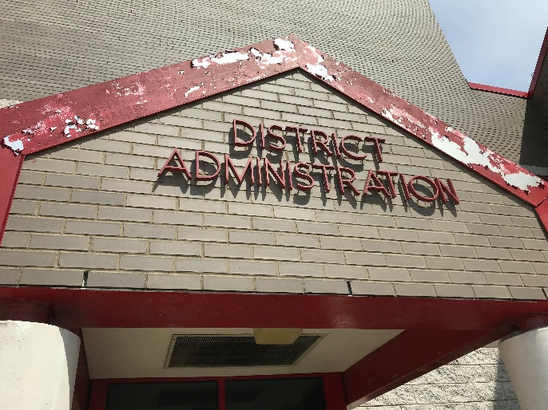
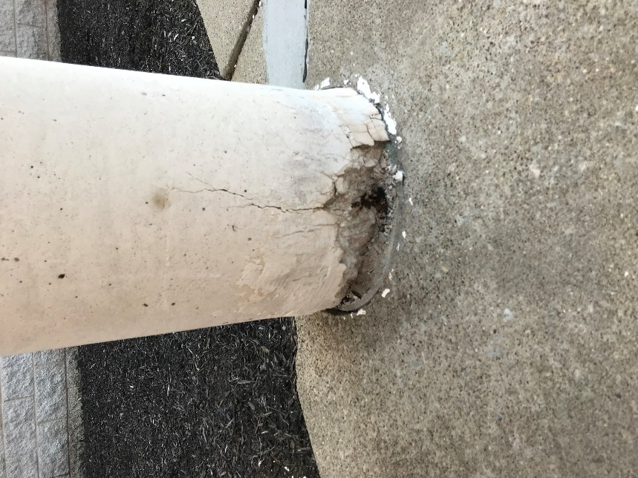
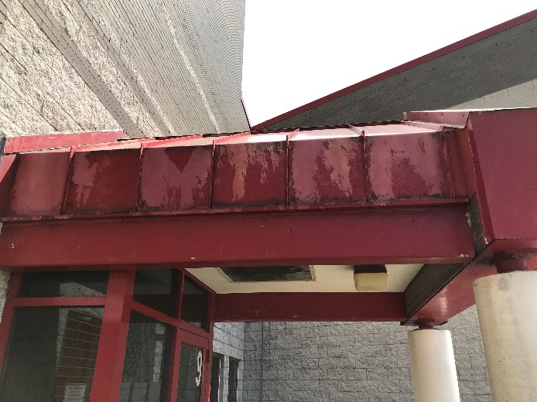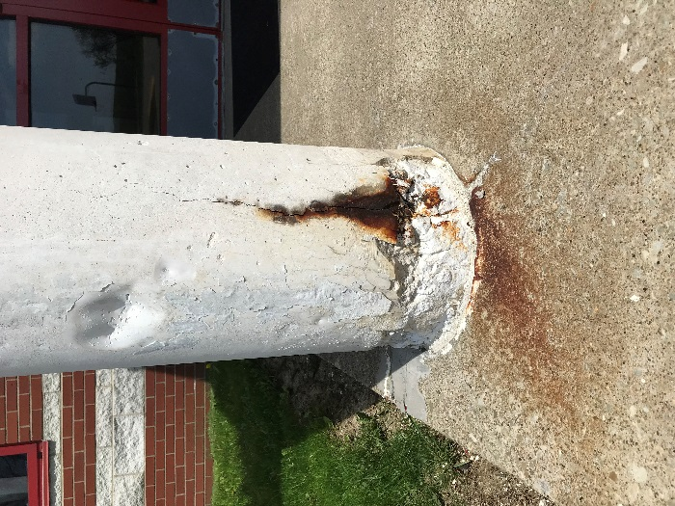
DISTRICT WIDE
BREAD TRUCK: $55,000 (Approx.): Purchased in 2002 – 16 years old
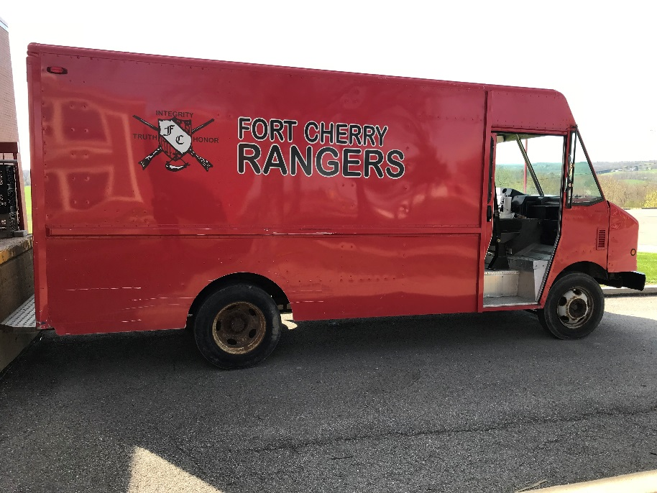
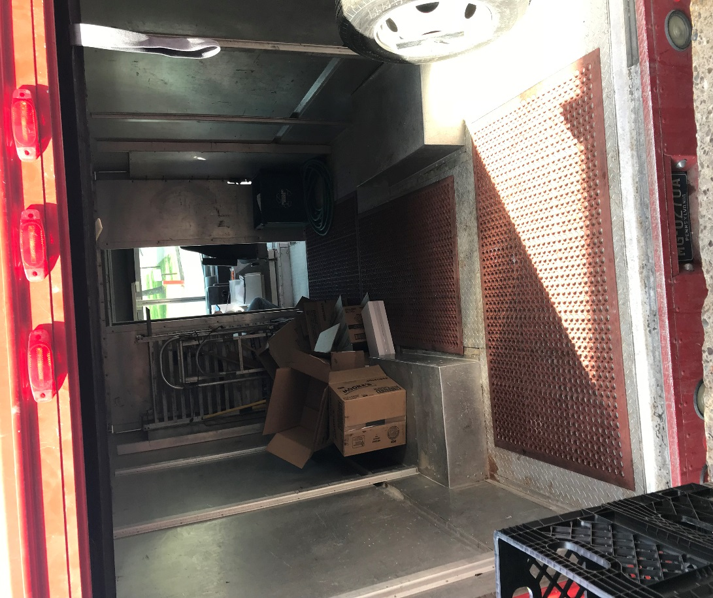
DISTRICT WIDE
SALT TRUCK / DUMP TRUCK: $62,500 (Approx.): Purchased in 2007 – 11 years old
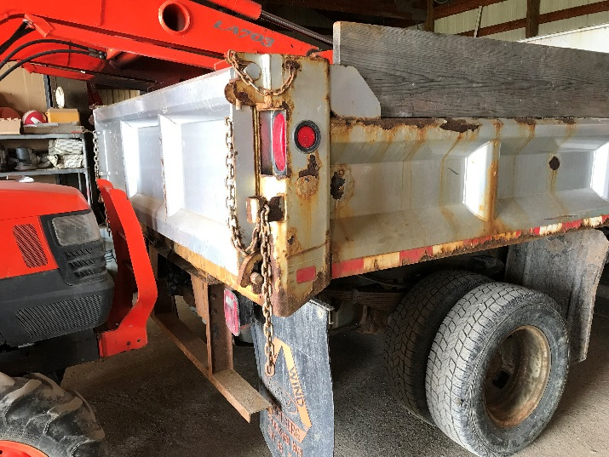
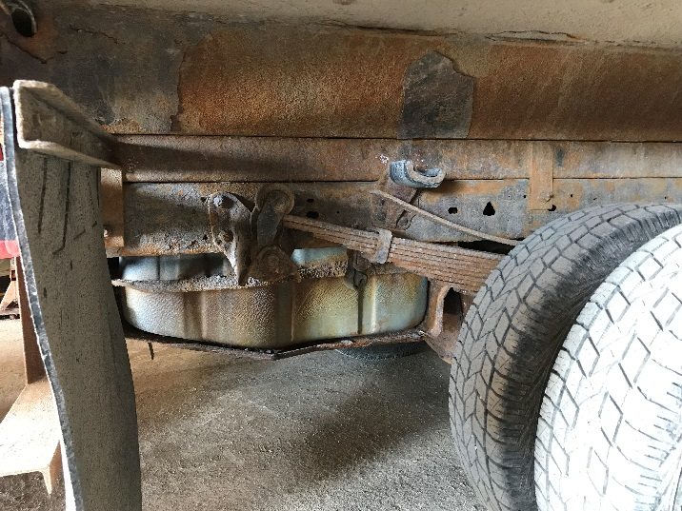
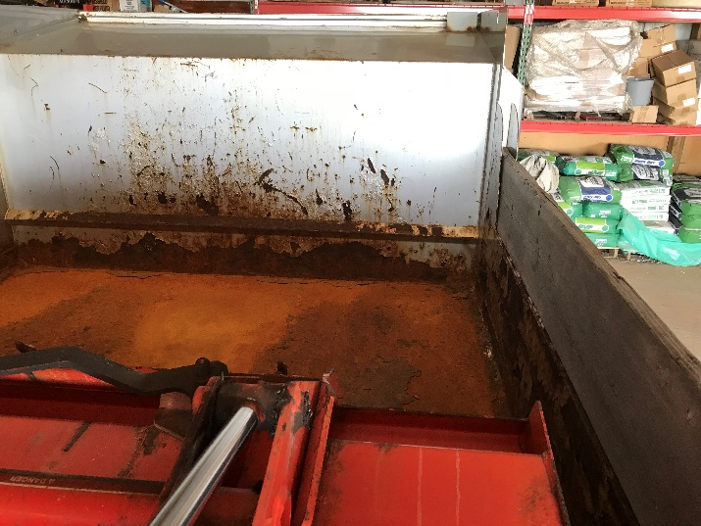

DISTRICT WIDE
POLE BARN UPGRADE: $10,000 (Approx.): Renovation ’95 – 23 years old
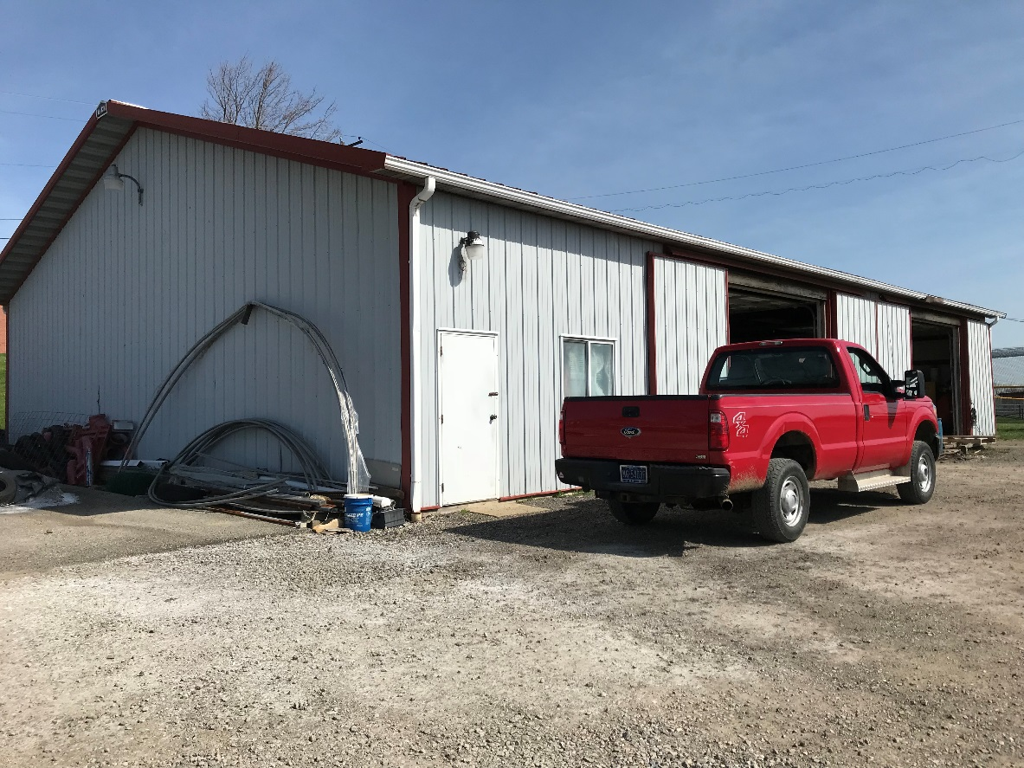
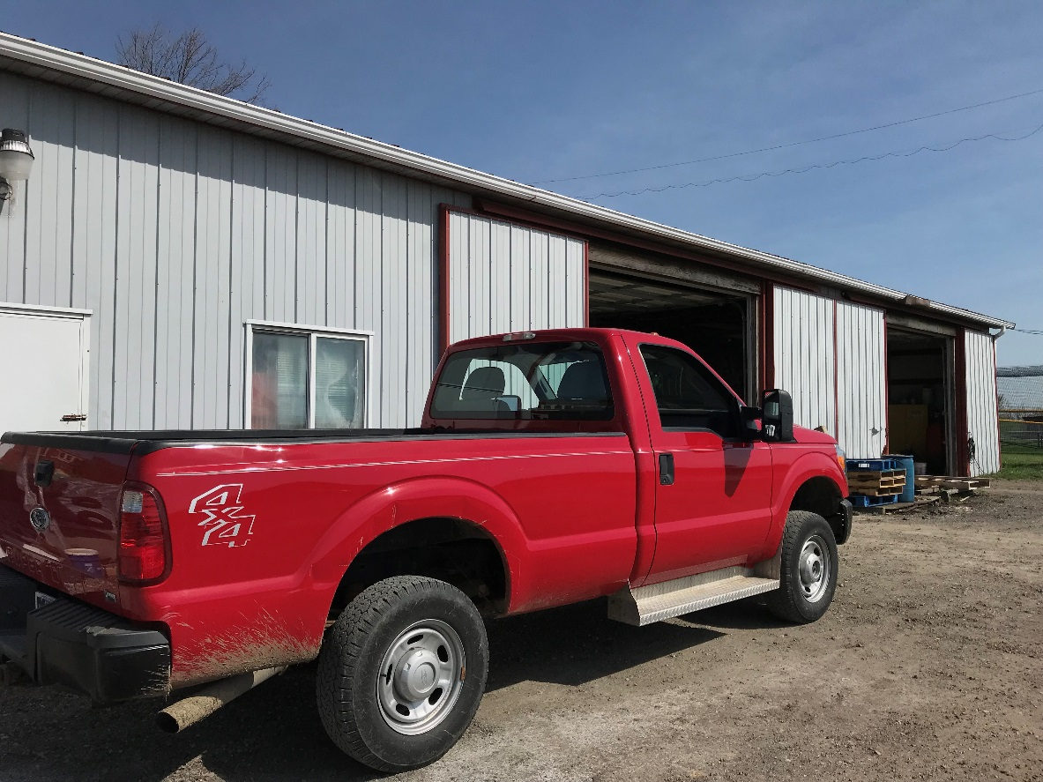
ELEMENTARY
PA SYSTEM: $29,800 (Approx.): Original - 30 years old
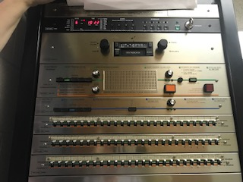
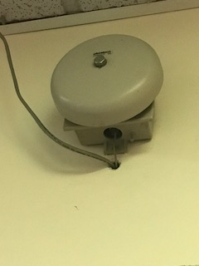

ELEMENTARY
CAFETERIA OVENS (4): $16,500 (Approx.): Original - 30 years old
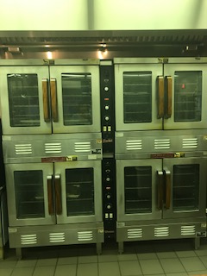

ELEMENTARY
LED LIGHTING: $40,000 (Approx.): Original - 30 years old
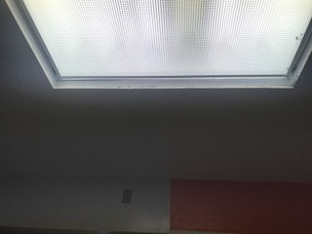
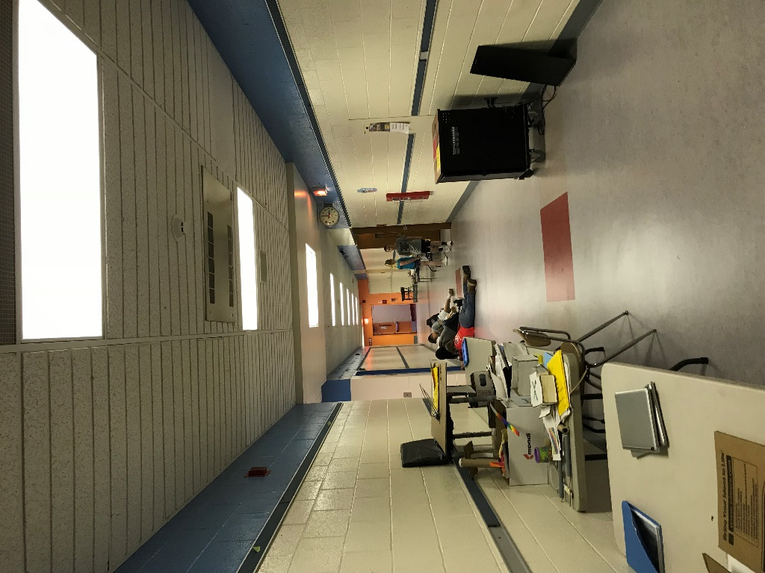

ELEMENTARY
CARPET: $96,000 (Approx.): Original - 30 years old
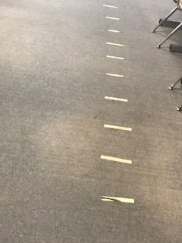
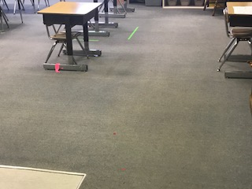

ELEMENTARY
ROOFTOP CONDENSING UNITS (12): $36,000 (Approx.): Original - 30 years old
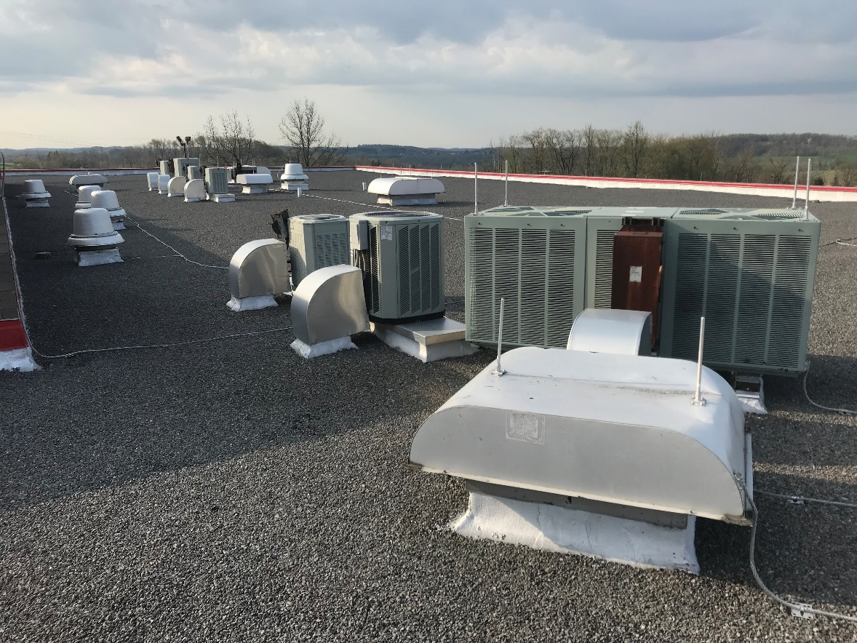
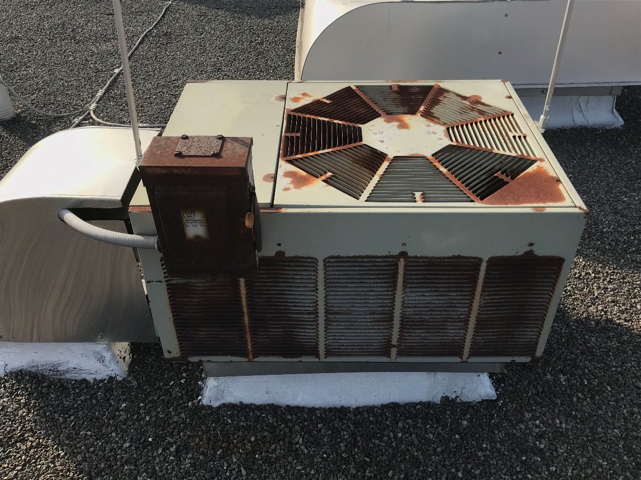
ELEMENTARY
OUTSIDE CANOPY: $250,000 (Approx.): Original - 30 years old
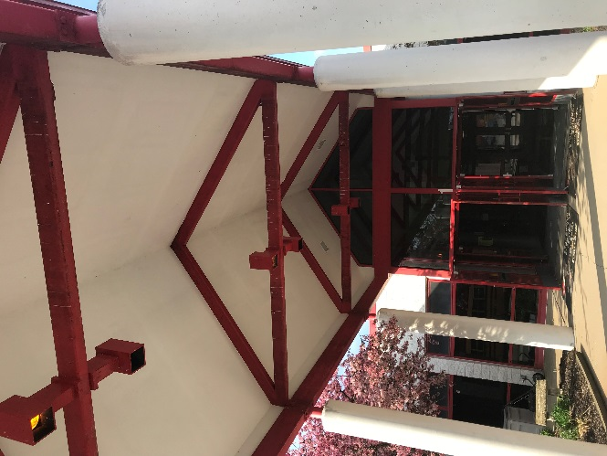
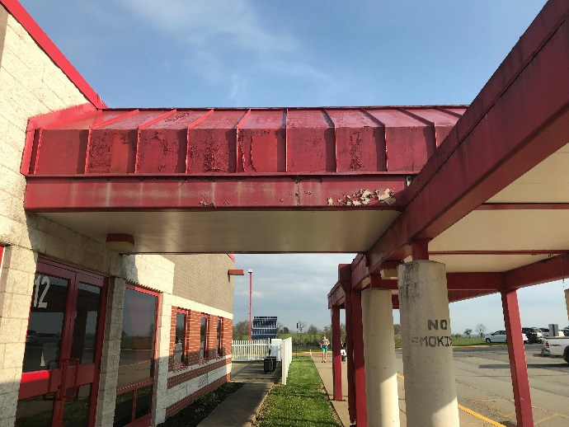
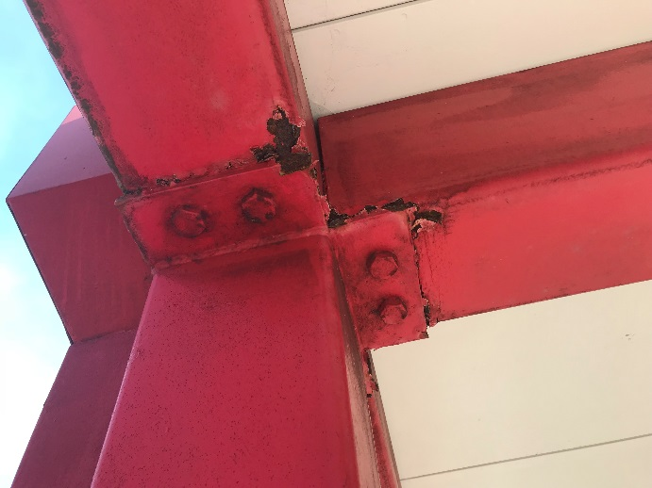

ELEMENTARY
DRIVEWAY / PARKING LOT: $100,000 (Approx.): Last paving was 2005/2007 – 11-13 years old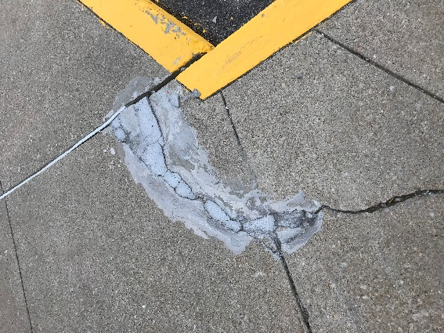
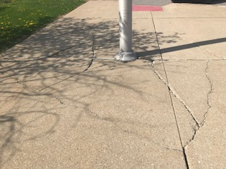
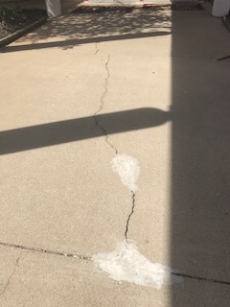
JR. HIGH / SR. HIGH
LOCKER ROOMS (GIRLS): ALL 3 LOCKER ROOM COST = $450,000 (Approx.): Renovation – 23 years old
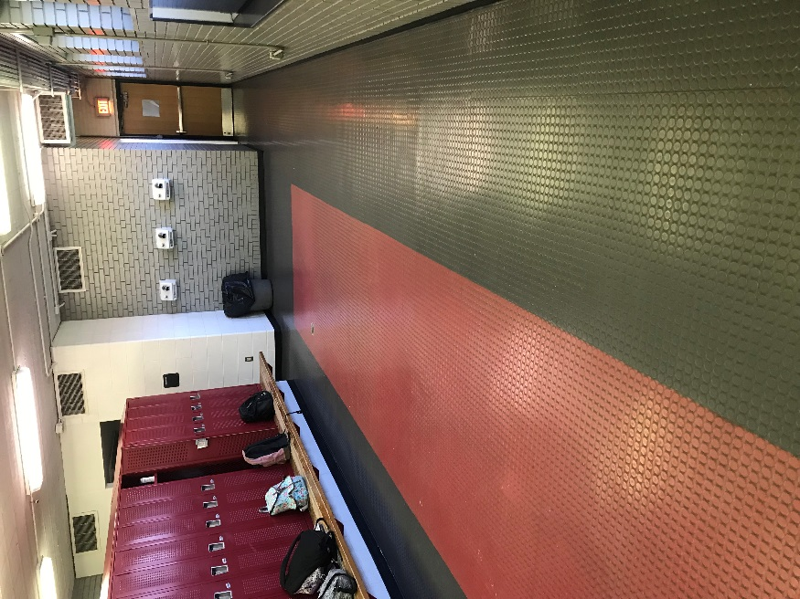
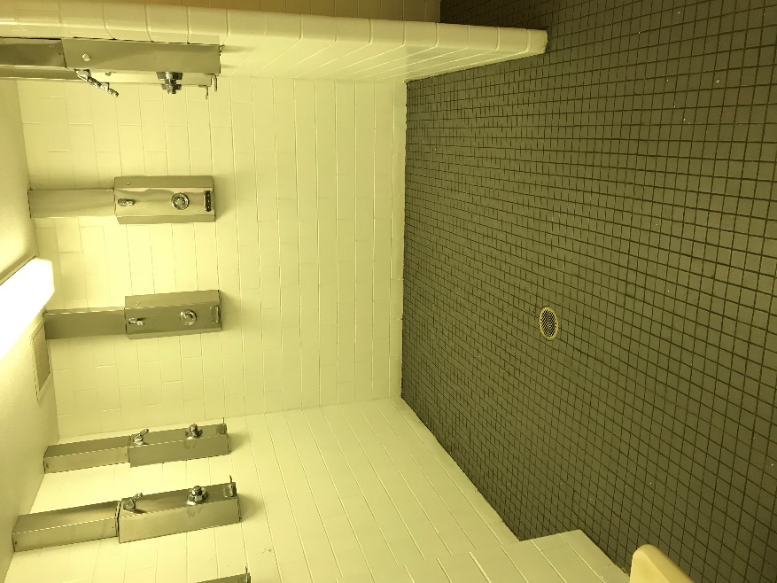
JR. HIGH / SR. HIGH
LOCKER ROOMS (BOYS): Renovation – 23 years old
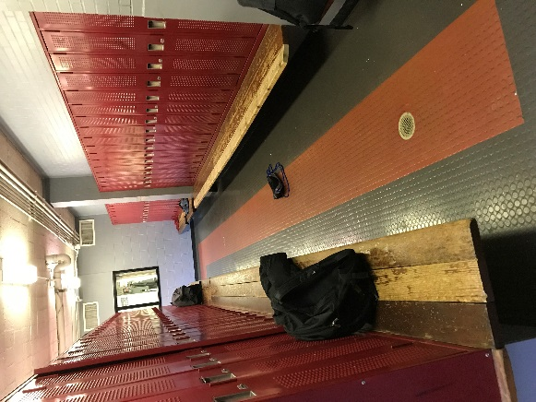
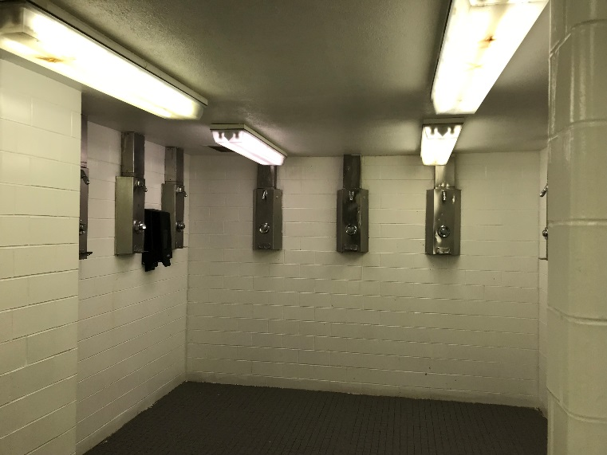
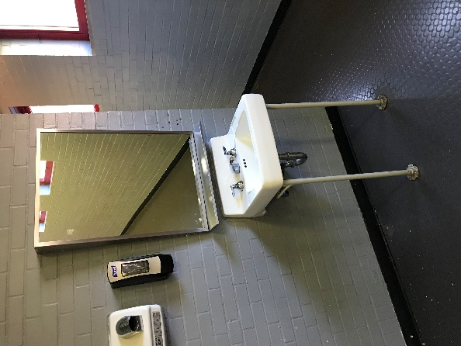
JR. HIGH / SR. HIGH
LOCKER ROOMS (FOOTBALL): Renovation – 23 years old
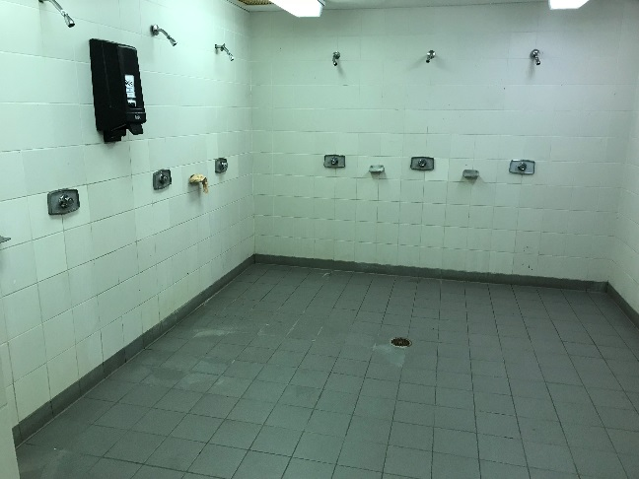
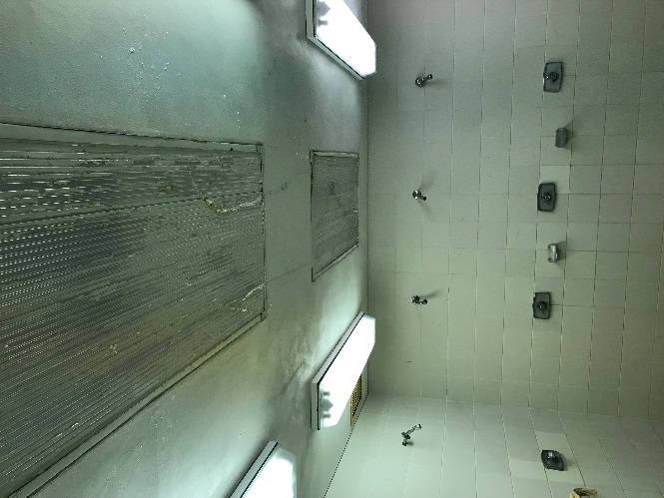
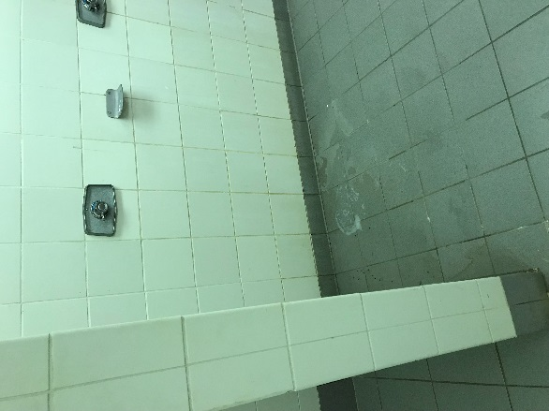
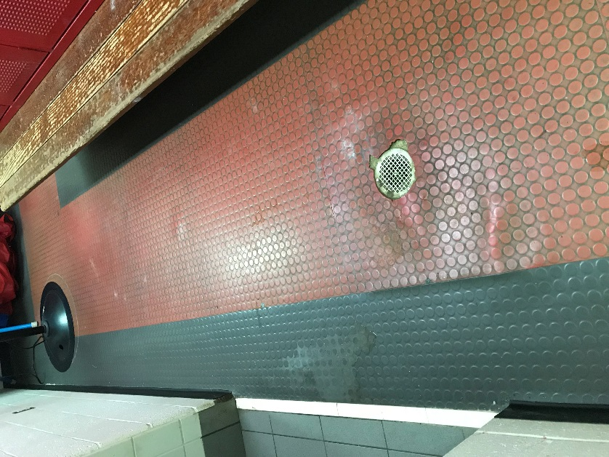
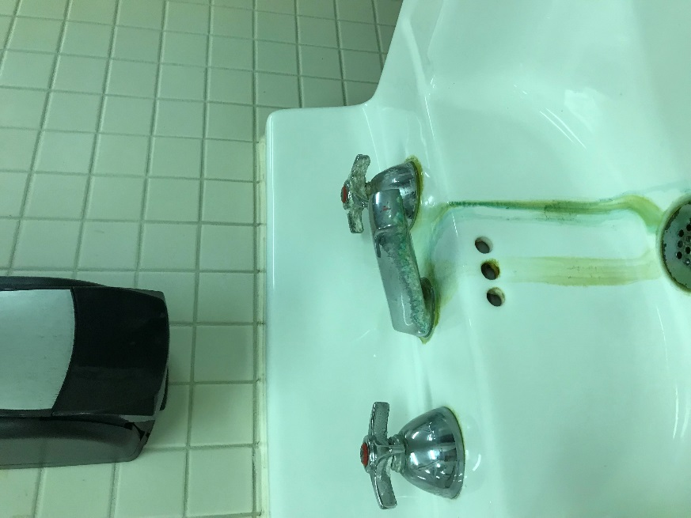

JR. HIGH / SR. HIGH
DRIVEWAY / PARKING LOT: $150,000 (Approx.): Last paving was 2005/2007 – 11-13 years old
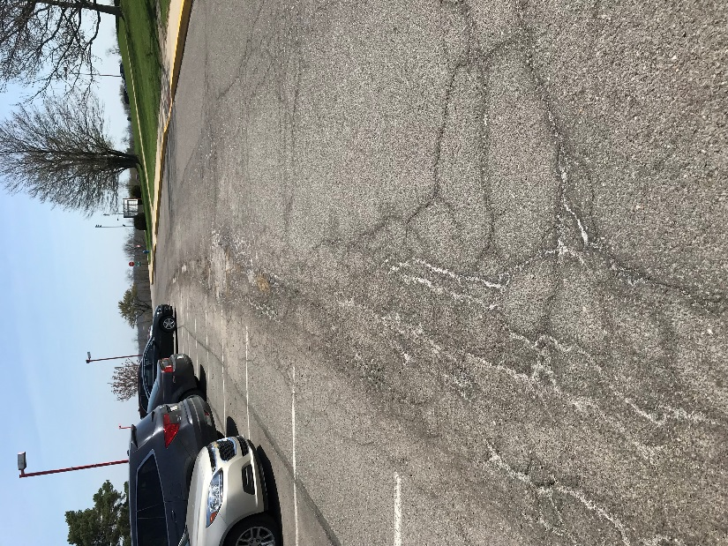
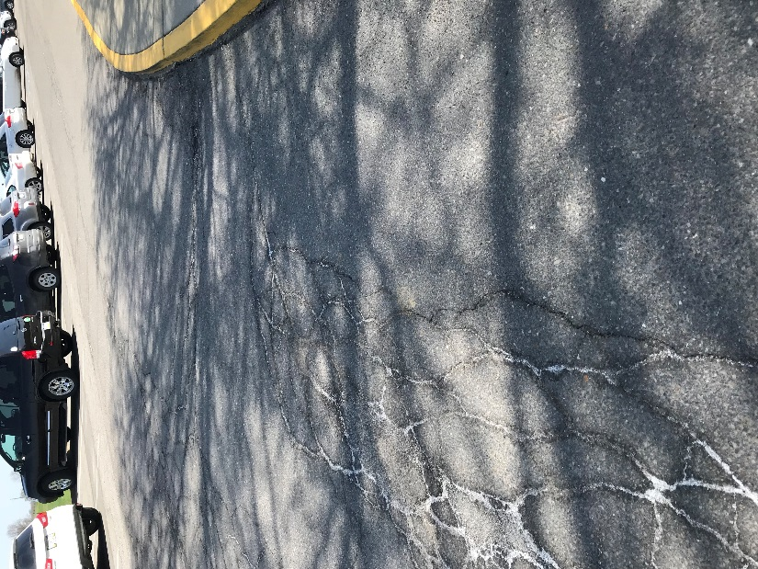

JR. HIGH / SR. HIGH
LED LIGHTING: $75,000 (Approx.): Renovation – 23 years old
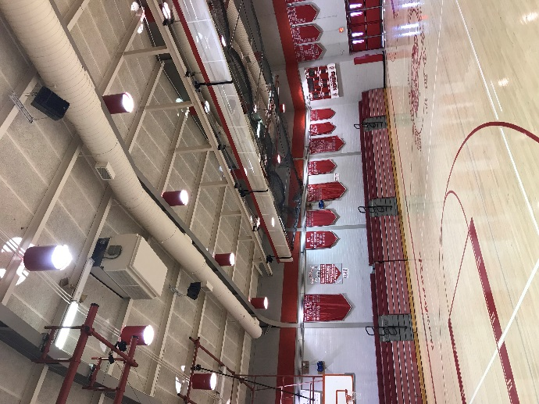
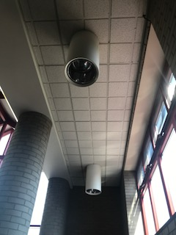
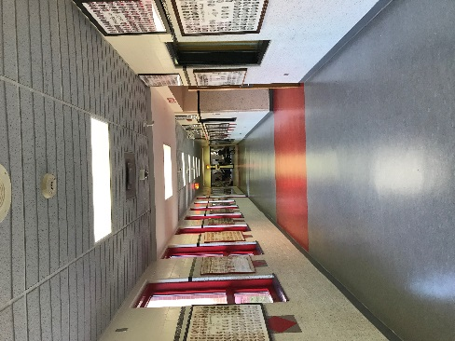

JR. HIGH / SR. HIGH
OUTSIDE CANOPY’S: $75,000 (Approx.): Original – 60/30 years old
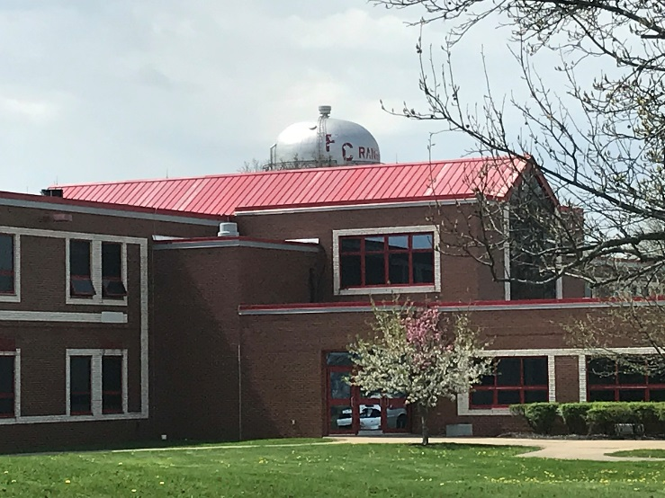
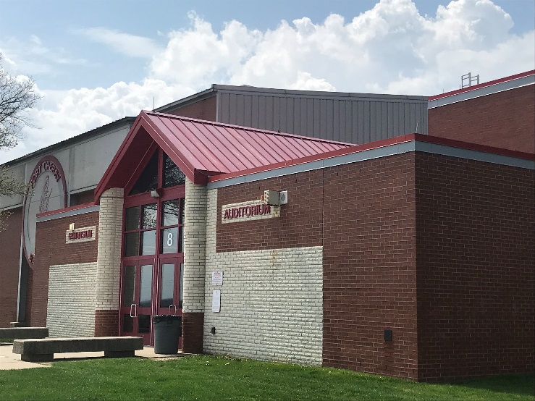
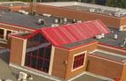

JR. HIGH / SR. HIGH
ROOFTOP CONDENSING UNITS (10): $30,000 (Approx.): Renovation - 23 years old
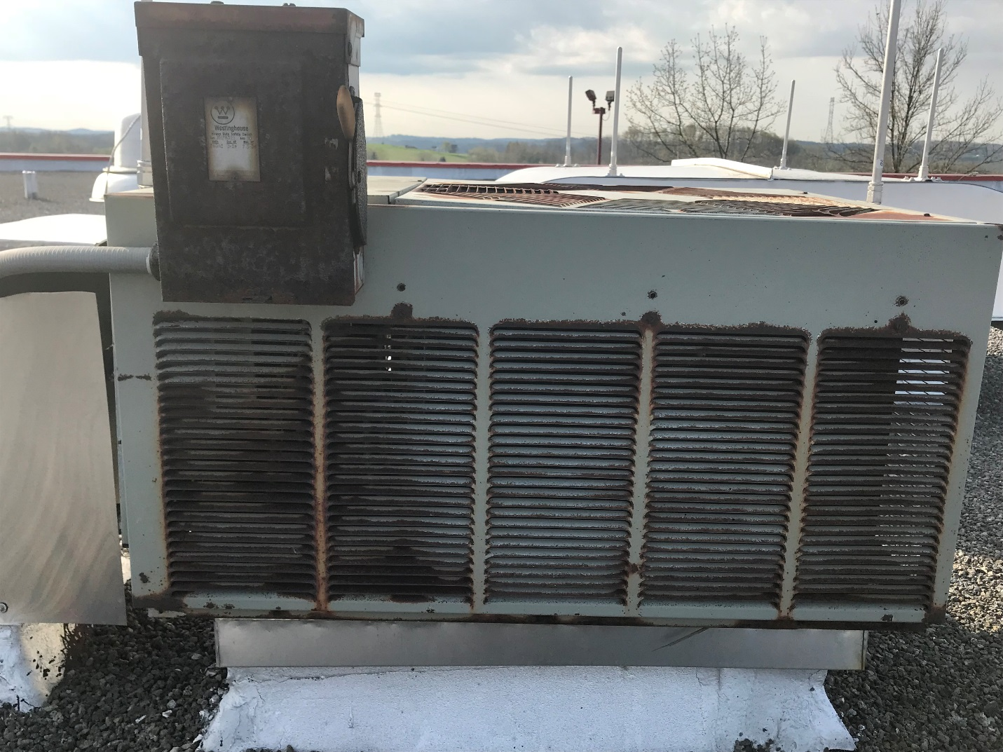

JR. HIGH / SR. HIGH
CARPET: $114,000 (Approx.): Original - 23 years old
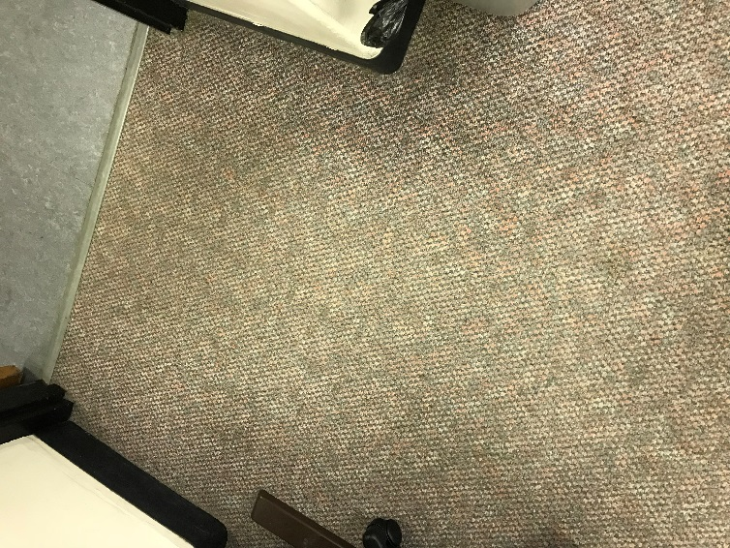
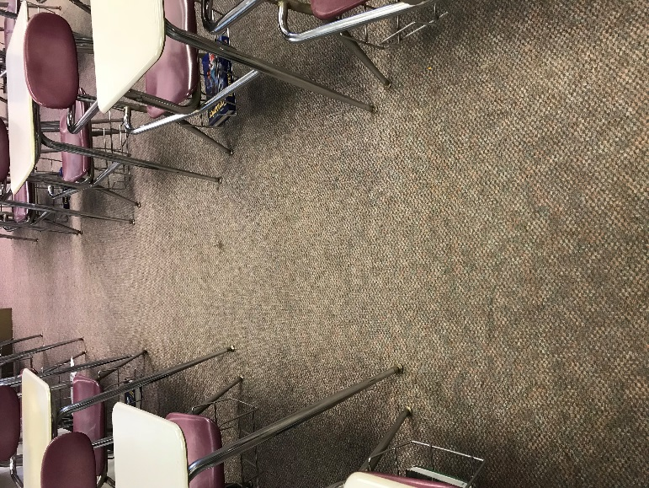

JR. HIGH / SR. HIGH
COFFEE SHOP (LIBRARY): $10,000 (Approx.)
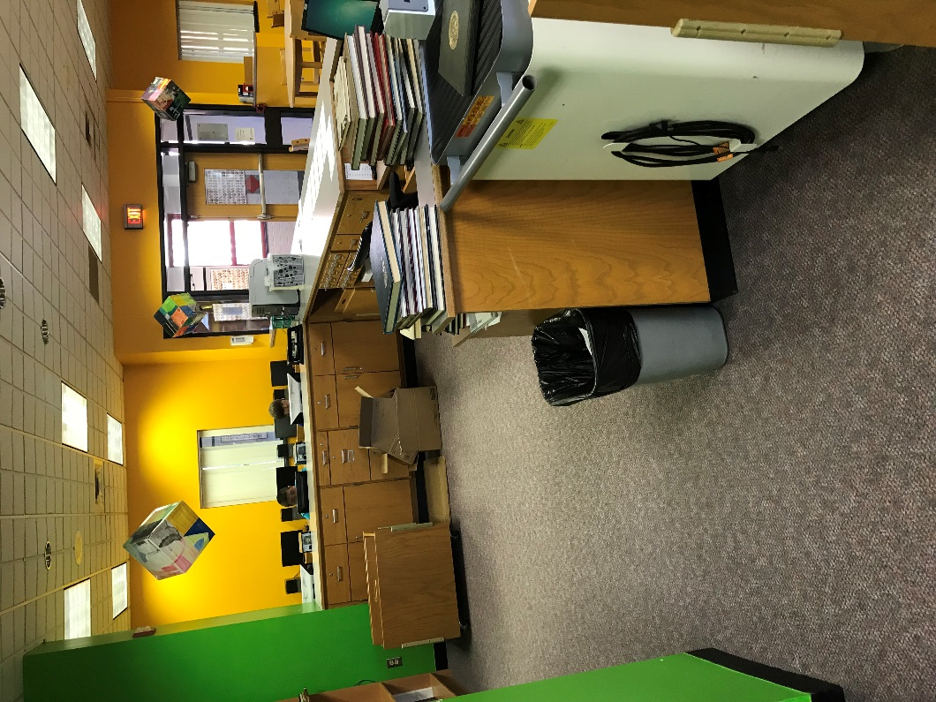
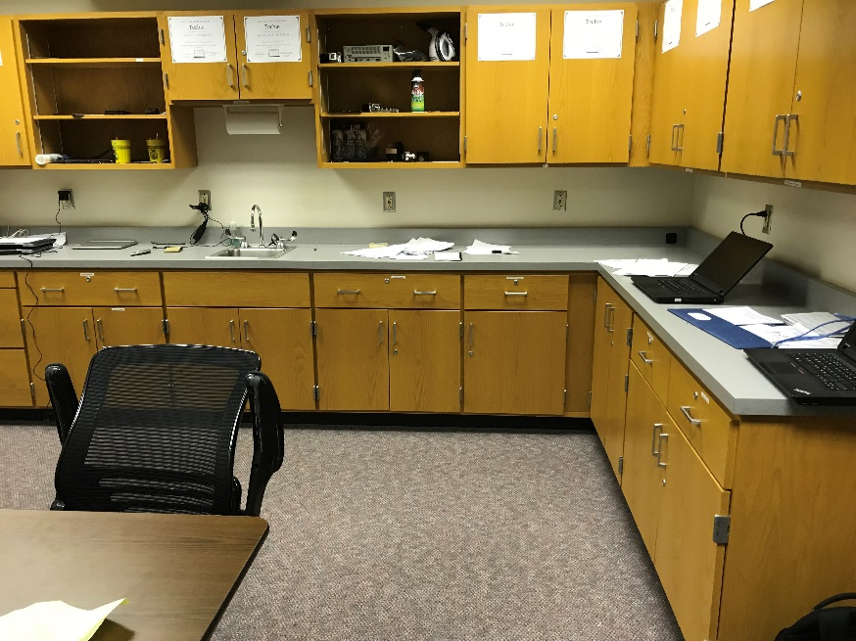

JR. HIGH / SR. HIGH
CHIMNEY: $130,000 (Approx.): Original - 60 years old
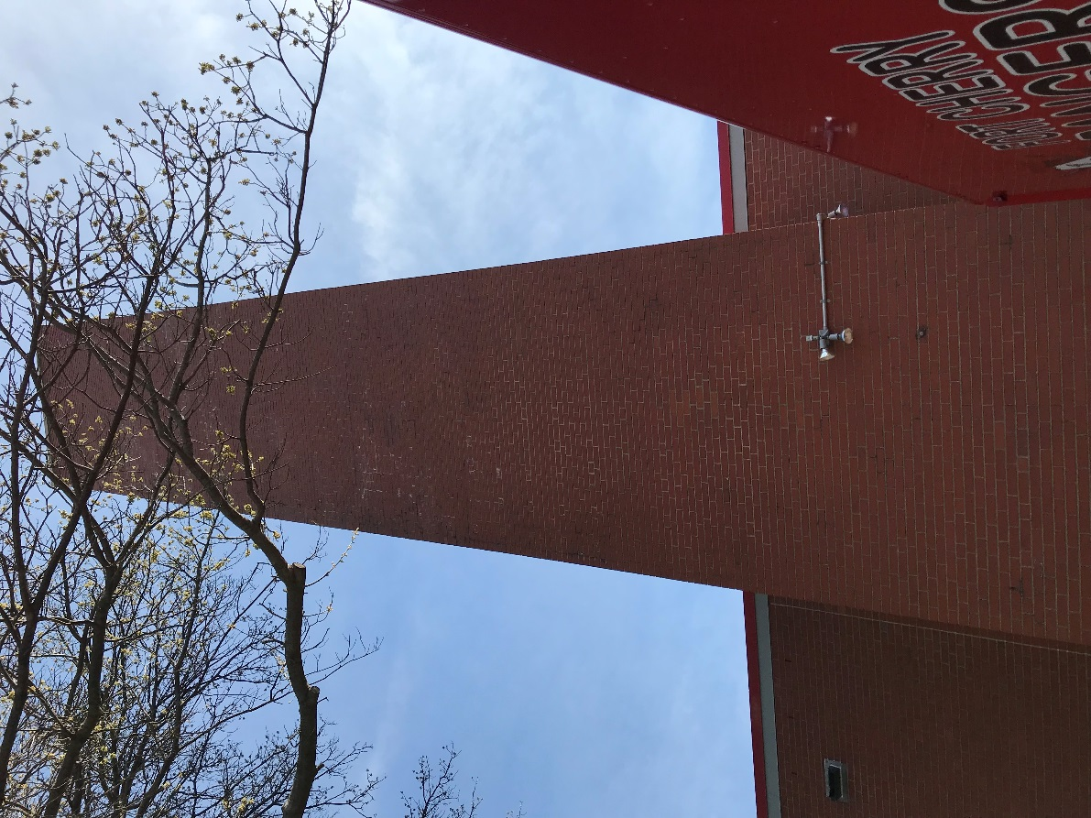

JR. HIGH / SR. HIGH
PA SYSTEM: $55,000 (Approx.): Renovation – 23 years old
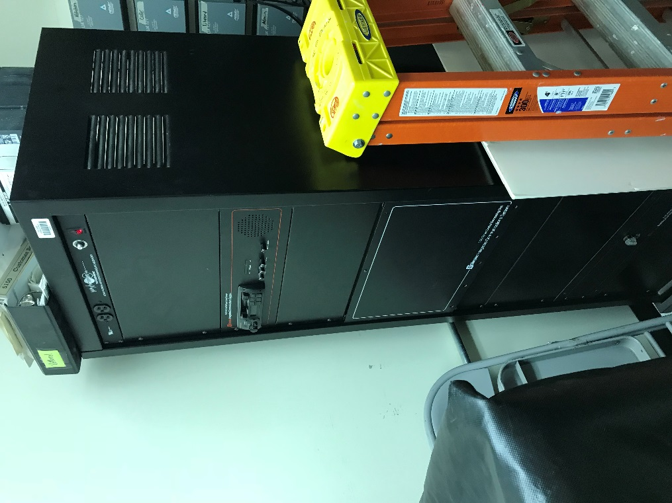
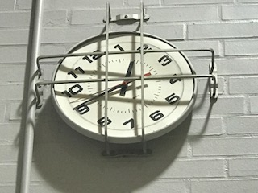

JR. HIGH / SR. HIGH
GYMNASIUM BLEACHERS: $125,000 (Approx.): Renovation – 23 years old
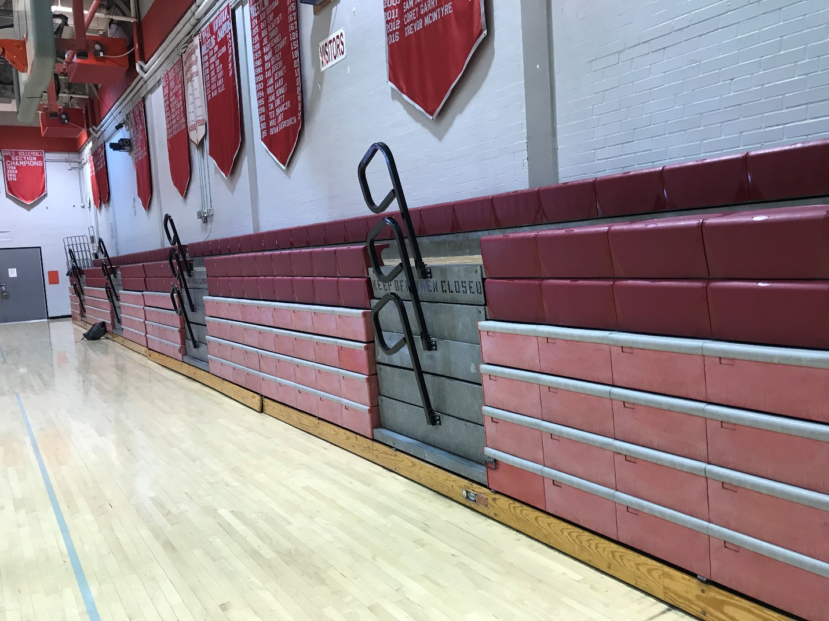

JR. HIGH / SR. HIGH
CAFETERIA OVENS (2): $8,100 (Approx.): Renovation - 23 years old (2)
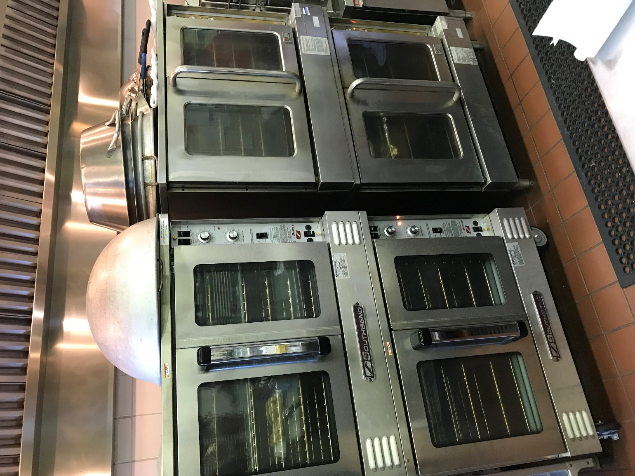

JR. HIGH / SR. HIGH
MAIN OFFICE CARPET: $8,000 (Approx.): Renovation – 23 years old
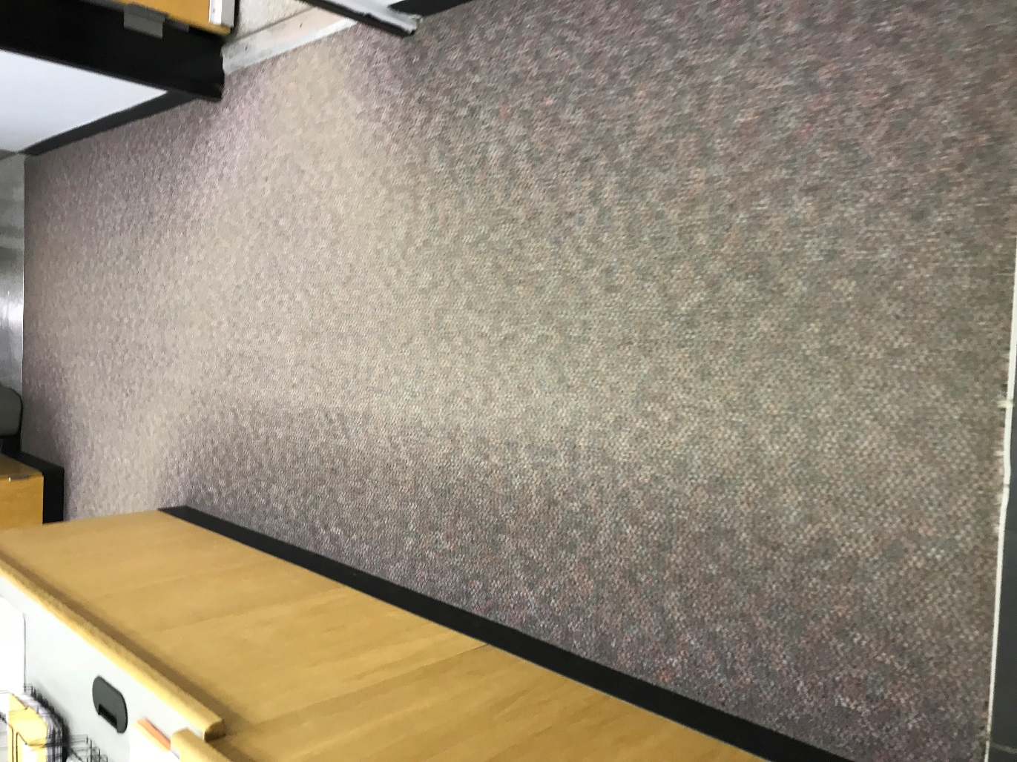

ELEMENTARY – MODULARS
(Maintenance Department will demo and remove in summer of 2018 – Costs budgeted within General Fund) – Constructed in 1997 – 21 years old
